Name ____________________
CS112
Exam 1

1) [3 points each] Match the term or terms from the list below to the following definitions. Note that not all terms will be used, some terms may be used more than once, and for some definitions more than one term may apply – include all terms that apply. The first one is done as an example.

__a, b_ Command(s) to move a sprite.

______ A method to coordinate two (or more) sprite’s actions.

______ A general programming construct that allows a program to easily repeat the same set of instructions.

______ A general programming construct that allows a program to “make a decision”.

______ A general programming construct that allows a piece of code to be named and then called by name.

______ A general programming construct that allows a program to store a value.

- move
- go to
- conditional
- loop
- block (or function/module/procedure)
- variable
- operation
- Cartesian
- wait
- broadcast/receive
- animation
- input
- output

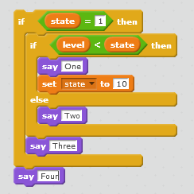
2) [9 points] Consider the code to the right. What will be “said” under the following conditions? (In several cases more than one thing will be said, list them all.)

- state = 1, level = 9

- state = 2, level = 1

- state = 1, level = 0

3) [3 points each] Multiple choice, put the letter of the correct answer in the blank to the left of the problem. The first one is done for you:

__d__ In Scratch commands to move sprites include:

- move
- go to
- glide to
- All of the above

____ You are creating a Scratch game in which the user looks down on a cat (see below). The player moves the cat around the screen pressing the F key to move forward and the left and right arrow keys to rotate the cat left or right. Which movement command(s) would you be most likely to use.
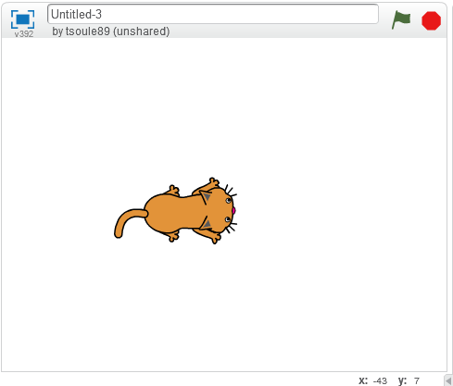
- go to
- glide to
- turn and move
- change X by and change Y by

____ In Scratch a walking animation is typically done by:

- Using a loop to move a few steps are a time
- Creating two or more costumes showing the sprite’s legs in different positions and switching between them.
- Using the animation command
- Including a video clip

____ A sprite controlled by the code block on the right will say “Hello!” if:
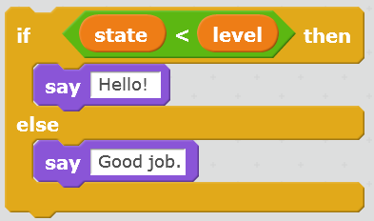
- The value stored in the state variable is less than the value stored in the level variable
- The value stored in the state variable is greater than the value stored in the level variable
- Never because “state” is alphabetically after “level”
- It will always say “Hello!”

____ In Scratch the location of a Sprite is defined by:

- It’s x,y position on a Cartesian plain
- It’s angle and radius in cylindrical coordinates
- The location of the mouse pointer
- All of the above

____ In Scratch ways to have the user control a sprite include:
- Responding to the user pressing keys
- Responding to the user moving the mouse
- Responding to the user waving in front of a camera (if one is available)
- All of the above

4) [3 points each] Mark each of the following statements as either True or False. You may explain your answers.

____ In Scratch, the only way to coordinate two sprites’ interactions is by having them use alternating wait commands.

____ In Scratch, multiple Sprites can receive the same message.

____ In Scratch, you are limited to using sprites from the predefined library.

____ In Scratch, variables cannot be used to represent negative numbers.

____ In Scratch, you are limited to using backgrounds form the predefined library of backgrounds.

____ In Scratch, there are multiple commands to get a sprite to turn.

____ One useful way to debug a Scratch program is to add some say commands to determine whether and when a particular block of code is reached.

____ If a sprite executes a go to command (e.g. go to x: 30 y: 30) it will always result in a visible change on the screen.

____ In Scratch, it would be possible to animate a sprite by making separate sprites representing the main sprites’ limbs and then have those limb sprites move.

5) [4 points] Consider the following block of code. If the user touches the sprite with the mouse, what will the sprite say?
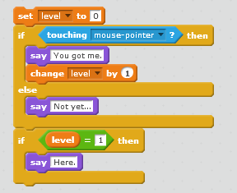

6) [5 points] Below are two Scratch programs, one on the left consisting of four blocks and one on the right consisting of one block. Will the two programs cause a sprite to behave the same way? If not, explain the difference.
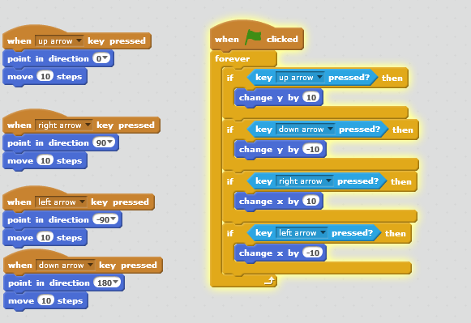

7) [5 points)] How many times does the following block of code say “Hello!” if the green flag is clicked?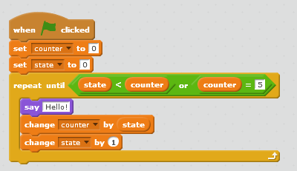
8) [5 points)] What is the difference between the go to and the glide to commands?

9) [15 points] Below are 5 Scratch blocks. Each of which is supposed to make a sprite say “Hello” 5 times when the green flag is clicked. Circle all of the blocks that will work, cross out the blocks that will fail. You may explain your answers.

